Basics of Computer Networks

A computer network is a telecommunication (tele means communication over distance) framework that allows digital devices (nodes) to exchange data via wired or wireless connections to share resources, such as hardware or software (e.g., the Internet). It is a collection of autonomous computers interconnected by a single technology. Networks vary in sizes, shapes, and forms, and they are often connected to create larger networks, with the Internet being the most prominent example-a network of networks.
Wireless devices

An autonomous computer means a computer that can operate independently. In a distributed system, autonomous computers are separate devices that communicate with each other over a network using agreed-upon protocols.
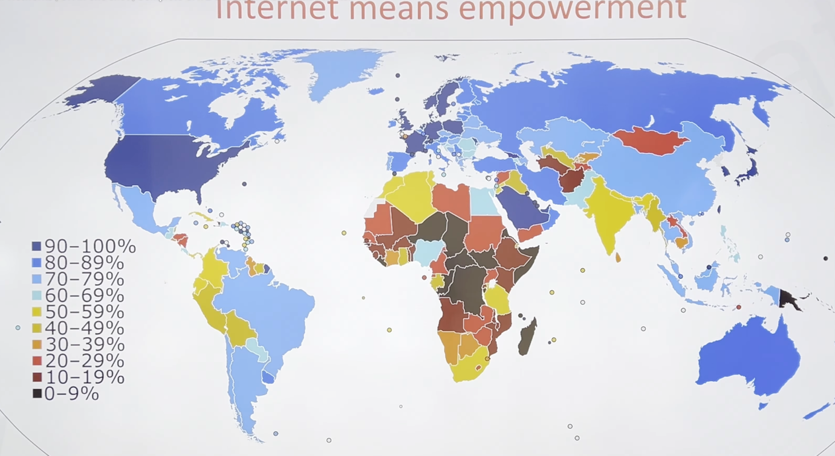

Internet usage shows how widely people in a country use the internet. Higher internet usage can contribute to economic growth by improving access to information, education, jobs, and business opportunities. Basically, this can lead to empowerment, as people gain more opportunities and resources to improve their lives.

Data communication:

Data communication is the exchange of data between two devices via a transmission medium. A data communication system has five components
- Message- information (data) to be communicated e.g. text, audio, video.
- Sender- device that sends the message (computer, phone, camera, etc.)
- Receiver- device that receives the message (computer, phone, television.
- Transmission medium - the physical path by which a message travels from sender to receiver.
- Protocol - the set of rules that governs data communication.

- Effectiveness of the data communications system depends on four fundamental characteristics:

- Delivery- Must deliver the data to correct destination.
- ﻿﻿﻿Accuracy- Must be delivered accurately without any error.(what you send should be delivered correctly)
- ﻿﻿﻿Timeliness- Must deliver the data promptly, sometime time in real time applications data delivered after time is useless.(if a message is sent now, it should be received in a short time shouldn’t take longer time for a receiver to receive )
- Jitter- Refers to variation in the packet arrival time i.e. the uneven delay between the packets (mismatch in audio and picture in a video) (if one packet is getting delayed the other should also follow that delay in order to be right)

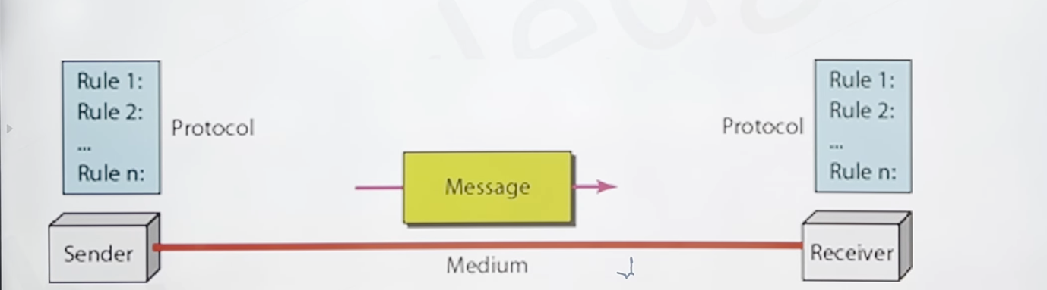

- Transmission mode between two systems can be categorised into three types:

- Simplex - The communication is unidirectional, like a one-way street. One device can always send; the other can always receive. E.g. radio, mouse.

- ﻿﻿The simplex mode can use the entire capacity of the channel to send data in one direction (which means that the sender can send the data to the receiver and the receiver can receive the data but won’t be able to reply to the sender; that’s why it called simplex)

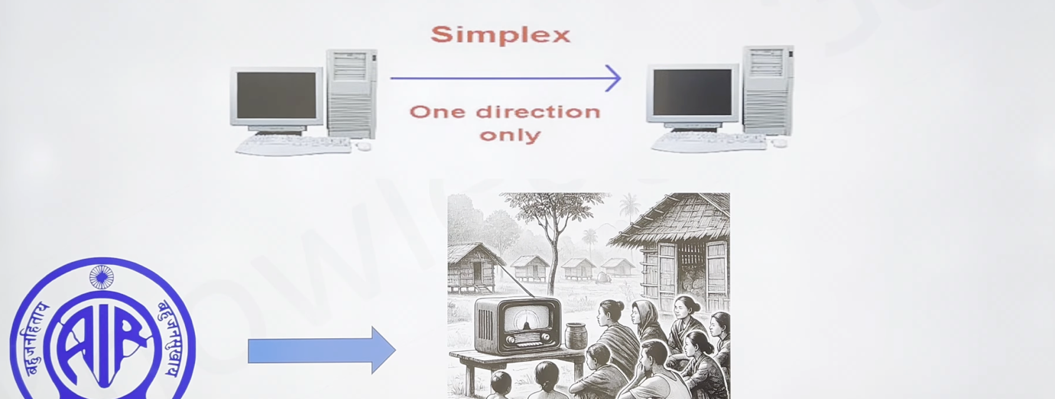

- Half duplex - each station can both transmit and receive, but not at the same time. E.g. like a one-lane road, walkie-talkie, etc.

- When one device is sending, the other can only receive, and vice versa.
- In a half-duplex transmission, the entire capacity of a channel is taken over by whichever of the two devices is transmitting at the time.
﻿﻿Walkie-talkies are half-duplex systems.
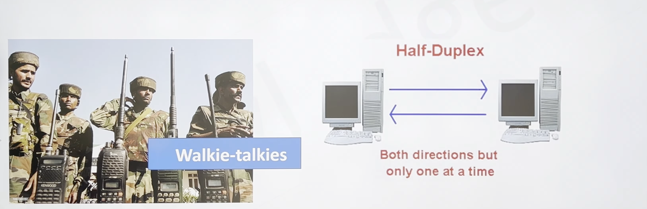

- Full duplex - both stations can transmit and receive at the same time. It is two half-duplex connections.( A simple way to understand it is that in simplex communication, one device sends data and the other receives it, with communication happening in only one direction.
In half-duplex communication, both devices can send and receive data, but not at the same time. One device sends while the other receives, and then they can switch roles.
In full-duplex communication, both devices can send and receive data simultaneously through the same communication channel, allowing two-way communication at the same time.
For example, imagine you are on a phone call with someone. You can both speak and hear each other at the same time. However, if you can hear the other person but they cannot hear you, that indicates a problem with the communication, rather than an example of full-duplex communication.
)

- A telephone network is an example of full-duplex mode: when two people are communicating by a telephone line, both can talk and listen at the same time.
- The channel capacity must be divided between the two directions.

- Network criteria-a network must be able to meet a certain number of criteria. The most important of these are performance, reliability and security.

- Performance - Can be measured in many ways including transit time, response time, number of users, type of transmission medium, capabilities of connected hardware's and efficiency of software.
- Reliability - Is a measure of frequency of failure and the time taken to resolve the failure.
- Security - Includes protecting data from unauthorised access, protecting data from damage and development.

- Types of connection-

- Point-to-point - A point-to-point connection provides a dedicated link between two devices. Most point-to-point connections use an actual length of wire or cable to connect the two ends, but other options, such as microwave or satellite links, are also possible.

- Multipoint - A multipoint (also called multidrop) connection is one in which more than two specific devices share a single link.

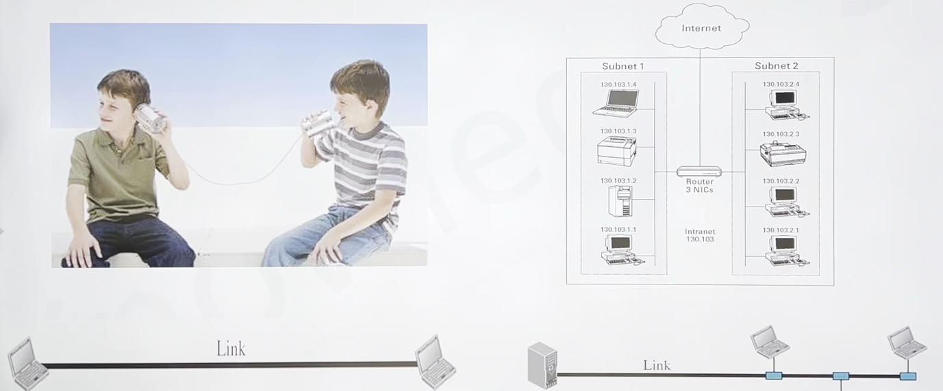

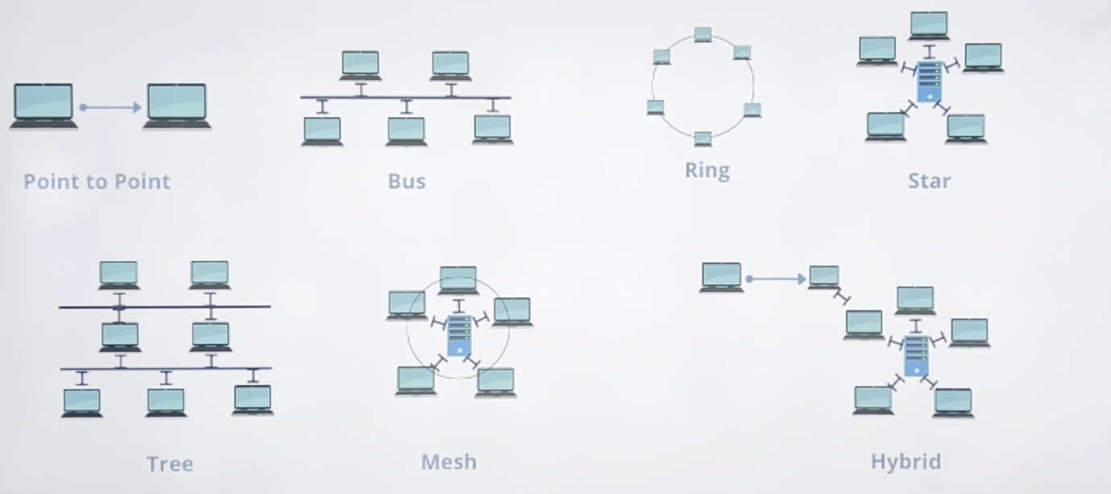

Mesh Topology:

- Mesh Topology
- In a mesh topology, each device has a dedicated point-to-point link to every other device.
- Requires n(n-1)/2 duplex-mode links for n nodes.

- Advantage:
Dedicated links eliminate traffic issues, provide robustness, ensure privacy, and make fault identification easy.
- Disadvantage:
﻿﻿Difficult installation, high wiring bulk, and expensive hardware requirements.
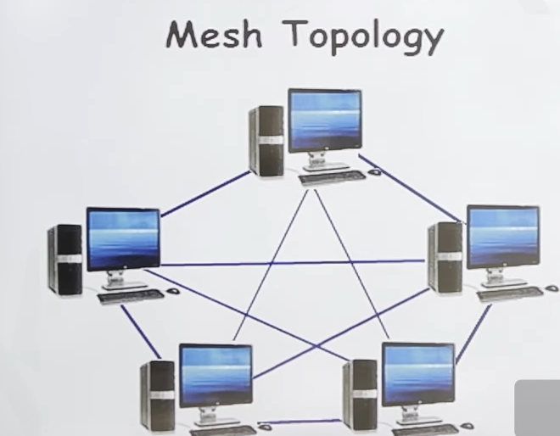

Star Topology:

- Each device has a dedicated point-to-point link to a central hub that manages communication between devices.

Advantage:
Easy to install, reconfigure, and identify faults. It is robust (failure of one link doesn’t affect the rest), and less expensive than a mesh topology.

Disadvantage:
﻿﻿The entire network depends on the central hub, and if it fails, the whole system is affected. Requires more cabling than other topologies.

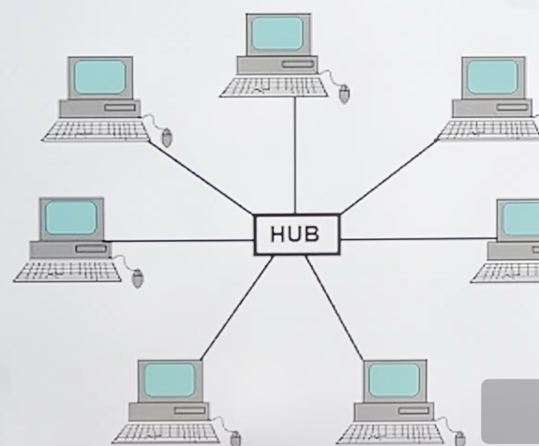

Bus Topology

- A multipoint topology where one long cable acts as a backbone connecting all devices. Devices connect to the backbone via drop lines and taps.
Advantage:
Easy to install and requires less cabling compared to mesh or star topologies.

Disadvantage:
Faults are difficult to isolate, and a break in the bus cable halts all transmissions. It is also &challenging to add new devices.

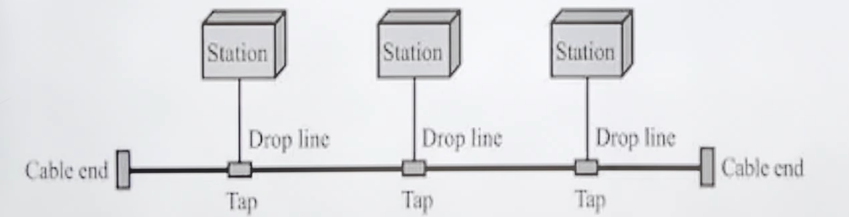

Ring Topology

- In a ring topology, each device connects directly to two adjacent devices, forming a closed loop. Data signals travel in one direction through each device until they reach their destination. Each device functions as a repeater, regenerating the signal before passing it to the next.

Advantages:
Simple installation and reconfiguration. Easier fault isolation.

Disadvantages:
﻿﻿ A single point of failure (like a disabled device) can disrupt the entire network.
